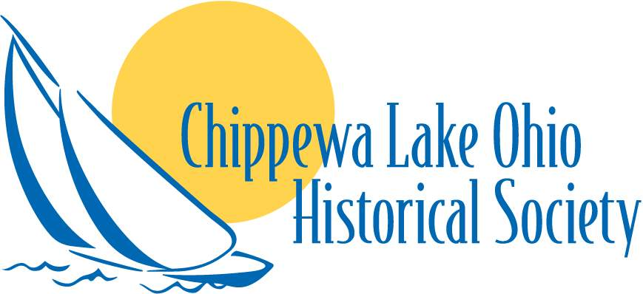
Box 106, 7464 Lake Road
Chippewa Lake OH 44215
chippewalakehistory@gmail.com
330/975-0656
www.clohs.org

2026
Annual Membership Form

Name: ________________________________________

Address: ______________________________________

______________________________________

Phone: ____________________________________

Email: ____________________________________

Individual $20.00 ___ Family $30.00 ___ | Lifetime $100.00 ___
For Credit Card, Paypal or Venmo:
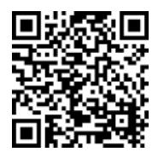
Or by mail, make your check payable to:
Chippewa Lake Ohio Historical Society (CLOHS)
P.O. Box 106
Chippewa Lake, OH 44215

Volunteering - Areas of Interest:
Historical Research Social Media / Marketing Grant Writing
Collections & Exhibits Fundraising Event Planning __________________
Donations in addition to your membership can be made out to the Chippewa Lake Ohio Historical Society. We are a 501(c)(3) nonprofit organization. Your donation is tax deductible to the fullest extent allowed by law.

